Born  in Brasil  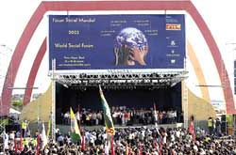 | 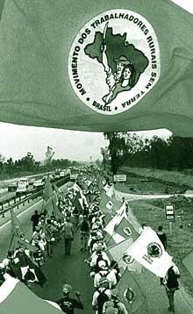
The WSF was proposed by a coalition of Brazilian civil society groups and progressive French groups, with much of the organisation undertaken by the ruling Workers Party (PT) whose leader Lula da Silva is the elected President of Brazil.
The PT retains a broad non-sectarian character quite unlike parties elsewhere in the world. However, this was preceded by an oppressive dictatorship that resulted in a very high degree of inequity. Brazil has 175 million people, is the eighth biggest economy in the world, but the wealth is so radically ill-distributed that 30 million live at sub-Saharan levels of poverty.
This is representative of the world we live in today and the critics of globalisation argue that world trade organizations perpetuate and widen this inequity. So it is not surprising that the WSF was born in Brazil in 2001.
In fact when Lula, 'the shoeshine president' came to power, he first fired the gourmet chef from the presidential staff and then cancelled the purchase of 12 fighter planes worth $700 million. He redirected the funds to his "Zero Hunger" programme.
Another influential figure was Tarso Genro, the Mayor of the town of Porto Alegre in Southern Brasil, brought the forum to his city — a meeting place for discussions on alternatives to globalisation and a counterpoint to the World Economic Forum (WEF) which meets at the same time as the WSF.
The WSF has been a huge success with other social forums opening up all over the world. Prominent among these is the European Social Forum and the Asian Social Forum. After hosting three sucessful WSF gatherings in Brasil it was decided to have it in the Indian city of Mumbai.
While other organizations with a social bent have difficulty in attracting the youth, not so the WSF. In fact, the forum has proved to be a unique meeting ground of individuals across all generations. Old Leftists trying to reinvent themselves rub shoulders with with young radicals trying to change the world in a different manner.
For a long time the anti-globalisation movement and the anti-imperialist current had been going their separate ways. In the aftermath of 11 September 2001, there has been a convergence between these two streams.
E-activism
Progressives now have a powerful new tool for organizing: the Internet.
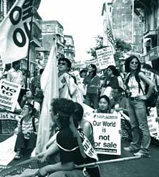
The World Social Forum is an open meeting place for reflective thinking, democratic debate of ideas, formulation of proposals, free exchange of experiences and interlinking for effective action.
Wait a minute. Doesn’t that sound a bit like the Internet which is probably one of the most democratic forums and has networked all kinds of people and groups from all parts of the world. Today the WSF has become a unique network of groups, NGOs, organisations and movements which meet once a year but otherwise stays in touch through the net.
The hundreds of "Social Forum" e-groups that have sprung up in the last couple of years are a testimony to that. Web-based organization took root three years ago in Seattle, when anti-globalization protesters coordinated events during the World Trade Organization's annual meeting. Roughly 50,000 people converged downtown, closing streets and leading to more than 400 arrests. On February 15th 2003, the biggest anit-war rallies in human history took place simultaneously in cities across the world against the impeding war in Iraq — all thanks to the internet.
We typed "World Social Forum" on Google and got about 125,000 web pages. That’s considerably behind "World Economic Forum", which got 322,000 pages. Obviously, people are finding ways to reach out, organise and protest inspite of of their newspapers, TV and radio controlled by powerful corporates.
A swarm of bees
Networking is the heart and soul of recent global protests
The coalitions of progressive organisations and individuals that turn up to either show solidarity at a WSF or to demonstrate and protest at annual meetings of the G8 or WEF are often described as a swarm of bees attacking the entrenched globalisation machine.
The slogans "Wherever they go, we shall be there!" and "We are everywhere" that are used to uphold the solidarity of the movement need not mean that the same group of individuals are everywhere, but that the alliance is united and present everywhere through their local struggles.
At all these gatherings the emphasis is both on raising a ruckus and on making connections between the global and local, among the working classes in the global north and south, between the food the world ingests and the way multinational corporations grow it. This movement, activist Anuradha Mittal says, is like "a swarm of bees that can't be cut off at the head or arm because when it attacks you are stung everywhere. That is the power of a people's movement."

All this happens because there is no central authority or leadership, which could be a good thing or a bad thing. Says writer Susan George, "There's a proposal to create a network of networks. It's a valuable idea but there are dangers. It could become centralised, with a homogeneous voice or a visible location. This would actually lead to the destruction of existing networks, which are being built every day and getting stronger every day. To have a sort of secretariat of a network means actually the opposite of a network. This could lead to struggles for power, which could end up destroying the existing networks."

